24.42: Placing a dielectric between the plates just results in the replacement of 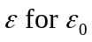in the derivation of Equation (24.20). One can follow exactly the procedure as shown for Equation (24.11).

